
NAME : STEPHEN KIMANI
ADMMISSION: BSCCS/2024/57444
COURSE : BACHELOR OF SCIENCE IN COMPUTER SCIENCE
UNIT: CODE: BIT4138
UNIT NAME: ADVANCED CRYPTOGRAPHY
LECTURER: MICHAEL NYORO
SEMESTER /ACADEMIC YEAR: SEMESTER 6
PROJECT DETAILS: IMPLEMENATION AND ANALYSIS OF CRYPTOGRAPHIC ALGORITHMS USING PYTHON
Technologies Used:
- Python 3
- Visual Studio Code
- Git
- OpenSSL
- PyCryptodome
- Windows PowerShell / Command Prompt

ONLINE PORTFOLIO/ GITHUB LINK
https://github.com/kimani985/advanced-cryptography-bit4138.git

Contents
WEEK 1: Cryptography Environment Setup 5
Installation and Configuration of Cryptography Development Environment 5
Figure 1:Successful installation of Python and Visual Studio Code for developing and testing cryptographic applications 5
Figure 2:Installation of cryptography libraries using pip, enabling implementation of encryption and decryption algorithms. 6
Figure 3:OpenSSL version verification confirming successful configuration of cryptographic command-line tools. 6
Figure 4:Execution of a Python test script verifying the development environment is operational. 7
Figure 5:Initialization of GitHub repository for version control and project documentation. 7
Reflection 7
WEEK 2 : Classical Cryptography and Cipher Design 9
Implementation of Classical Encryption Algorithms 9
Figure 6:Caesar Cipher implementation demonstrating character shifting using a fixed encryption key. 9
Figure 7:Successful encryption and decryption outputs generated by the implemented cipher algorithm. 10
Figure 8: Input validation process preventing invalid plaintext entries during encryption. 11
Figure 9:Vigenère Cipher implementation demonstrating keyword-based encryption. 12
Figure 10: Cipher testing results obtained using different messages and encryption keys. 12
Reflection 12
WEEK 3: Stream Ciphers and Randomness Testing 13
Implementation of Stream Cipher Systems and Random Sequence Analysis 13
Figure 11:Implementation of a Linear Feedback Shift Register (LFSR) used to generate pseudorandom sequences. 13
Figure 12:Generated pseudorandom binary sequence produced by the implemented LFSR. 13
Figure 13:Statistical randomness testing results showing distribution of generated binary values. 14
Figure 14:RC4-style stream cipher simulation demonstrating encryption using a generated keystream. 14
Figure 15:Performance evaluation results showing execution time during encryption operations. 15
Reflection 15
WEEK 4: Block Cipher Design and AES 16
Advanced Encryption Standard (AES) and Block Cipher Operations 16
Figure 16:AES encryption program implementing symmetric key cryptography for secure file protection 16
Figure 17: AES symmetric key generation process used for encryption and decryption operations 17
Figure 18:Successful encryption of a text file using the generated AES key. 17
Figure 19: Successful decryption process restoring the original file contents. 17
Figure 20:AES performance evaluation showing execution time during encryption 18
Reflection 18
WEEK 5 : Public Key Cryptography (RSA) 19
Implementation of RSA encryption and Key Management 19
Figure 21:Generation of RSA public and private key pairs used for secure communication. 19
Figure 22:Encryption of plaintext using the RSA public key. 19
Figure 23:Successful recovery of the original message using the RSA private key. 20
Figure 24:Simulation of secure communication using RSA public and private key cryptography. 20
Figure 25:RSA testing and validation confirming successful encryption and decryption operations. 20
Reflection 20

WEEK 1: Cryptography Environment Setup

Installation and Configuration of Cryptography Development Environment
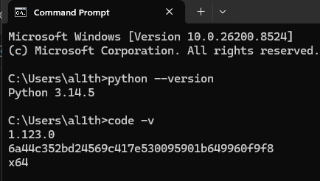
Figure 1: Successful installation of Python and Visual Studio Code for developing and testing cryptographic applications.

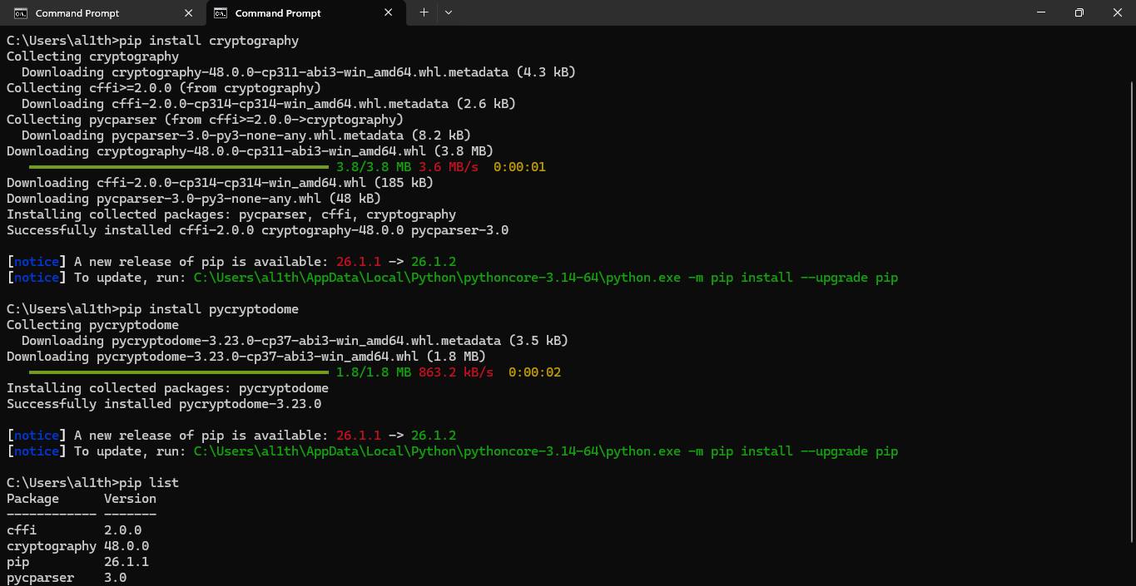

Figure 2: Installation of cryptography libraries using pip, enabling implementation of encryption and decryption algorithms.
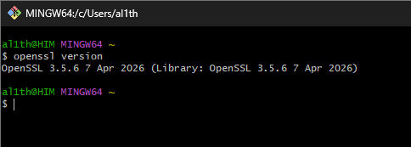

Figure 3: OpenSSL version verification confirming successful configuration of cryptographic command-line tools.

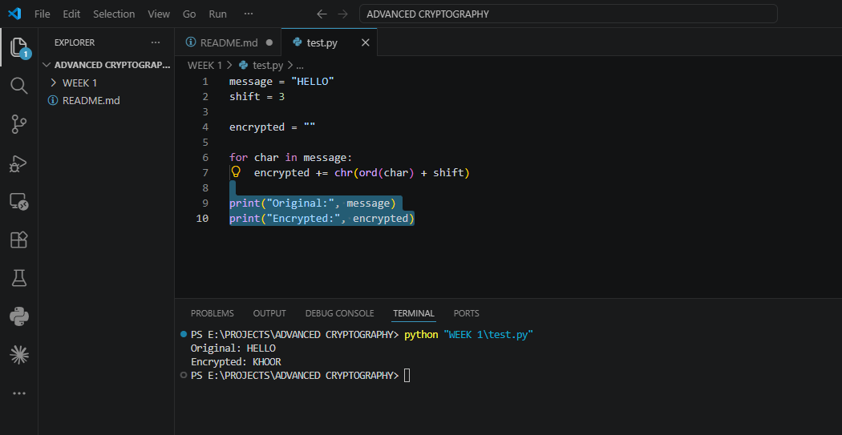

Figure 4: Execution of a Python test script verifying the development environment is operational.

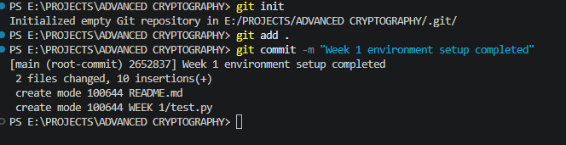

Figure 5: Initialization of GitHub repository for version control and project documentation.

Reflection
This week focused on setting up the cryptography development environment. Python, VS Code, OpenSSL, and required libraries were successfully installed and tested. GitHub was configured for version control. The environment is now ready for implementing and testing cryptographic algorithms.

WEEK 2: Classical Cryptography and Cipher Design

Implementation of Classical Encryption Algorithms
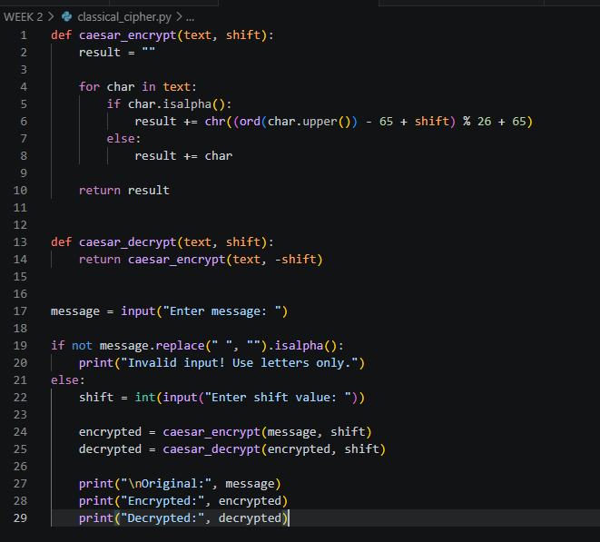

Figure 6: Caesar Cipher implementation demonstrating character shifting using a fixed encryption key.
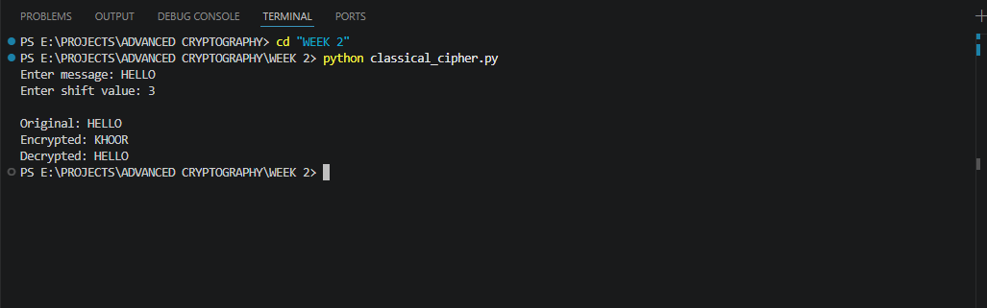

Figure 7: Successful encryption and decryption outputs generated by the implemented cipher algorithm.

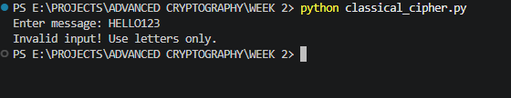

Figure 8: Input validation process preventing invalid plaintext entries during encryption.
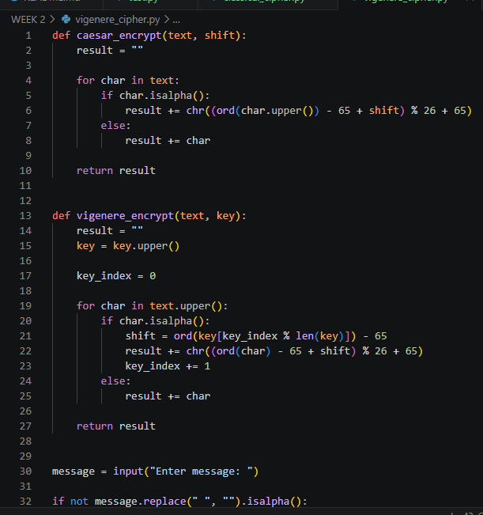

Figure 9: Vigenère Cipher implementation demonstrating keyword-based encryption.
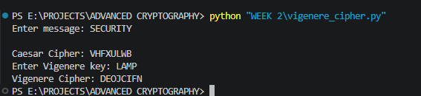

Figure 10: Cipher testing results obtained using different messages and encryption keys.

Reflection
The implementation of Caesar and Vigenère ciphers demonstrated the importance of encryption keys in protecting information. Testing showed that Vigenère Cipher provides stronger security through keyword-based encryption, while Caesar Cipher remains vulnerable to simple cryptanalysis techniques.

WEEK 3: Stream Ciphers and Randomness Testing

Implementation of Stream Cipher Systems and Random Sequence Analysis

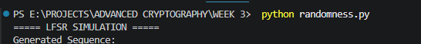

Figure 11: Implementation of a Linear Feedback Shift Register (LFSR) used to generate pseudorandom sequences.

Figure 12: Generated pseudorandom binary sequence produced by the implemented LFSR.

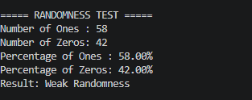

Figure 13: Statistical randomness testing results showing distribution of generated binary values.
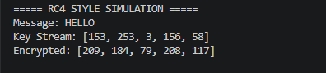

Figure 14: RC4-style stream cipher simulation demonstrating encryption using a generated keystream.
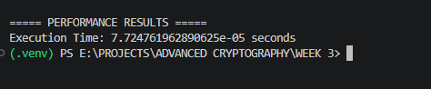

Figure 15: Performance evaluation results showing execution time during encryption operations.

Reflection
This week focused on pseudorandom sequence generation and stream cipher concepts. An LFSR was implemented to generate binary sequences, and statistical testing was performed to evaluate randomness. An RC4-style simulation demonstrated how stream ciphers use keystreams to encrypt data efficiently.

WEEK 4: Block Cipher Design and AES

Advanced Encryption Standard (AES) and Block Cipher Operations
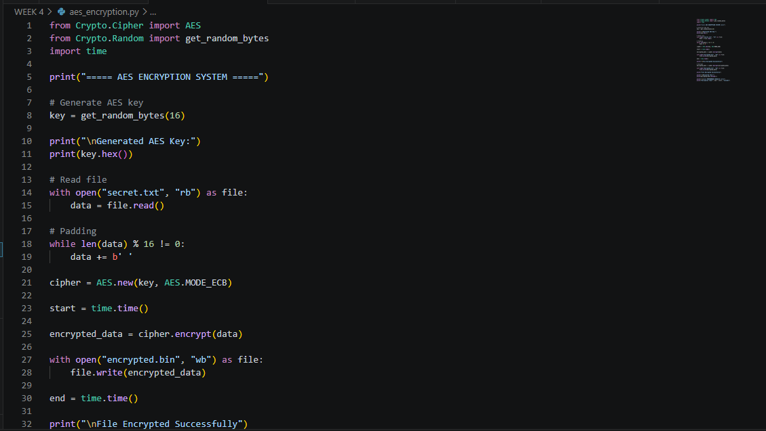

Figure 16: AES encryption program implementing symmetric key cryptography for secure file protection

Figure 17: AES symmetric key generation process used for encryption and decryption operations
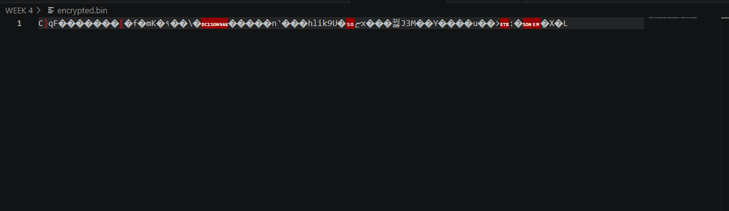

Figure 18: Successful encryption of a text file using the generated AES key.
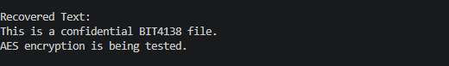

Figure 19: Successful decryption process restoring the original file contents.

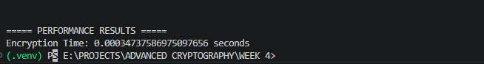
Figure 20: AES performance evaluation showing execution time during encryption.

Reflection
AES encryption was implemented to protect files using symmetric cryptography. Secure key generation, encryption, and decryption processes were successfully tested. The practical activity demonstrated the importance of key management and the effectiveness of AES in securing sensitive information.

WEEK 5: Public Key Cryptography (RSA)

Implementation of RSA encryption and Key Management
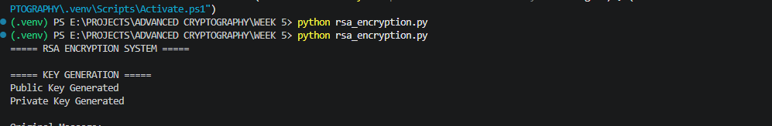

Figure 21: Generation of RSA public and private key pairs used for secure communication.
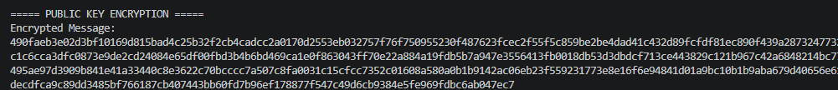

Figure 22: Encryption of plaintext using the RSA public key.
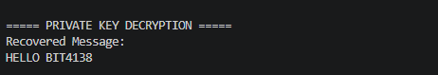

Figure 23: Successful recovery of the original message using the RSA private key.
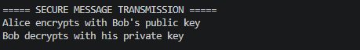

Figure 24: Simulation of secure communication using RSA public and private key cryptography.
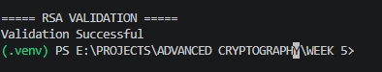

Figure 25: RSA testing and validation confirming successful encryption and decryption operations.

Reflection
RSA encryption demonstrated the principles of asymmetric cryptography through the use of public and private keys. Secure message transmission and decryption were successfully tested. The practical activity highlighted the advantages of RSA in protecting sensitive information and enabling secure communication.

